DBMS PROJECT

E- WALLET

Database e- wallet consist of 4 tables-

1. Customers

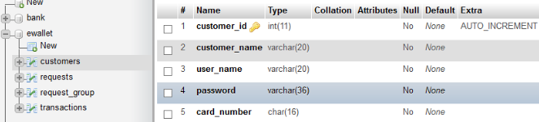

1. Request

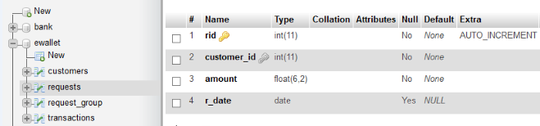

1. Request group

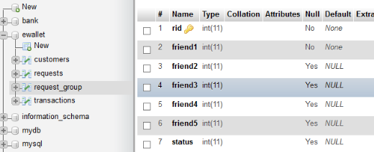

1. Transactions

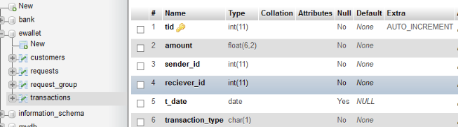

To use in our project, we have created a sample abstract bank database which will be fetched from the bank.

Bank database has following tables-

1)Account

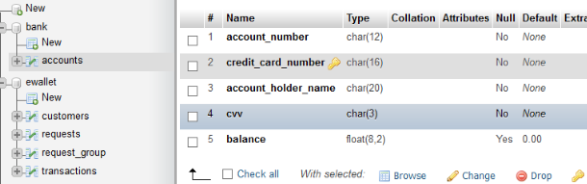

All the tables in project are normalised to 3NF form .

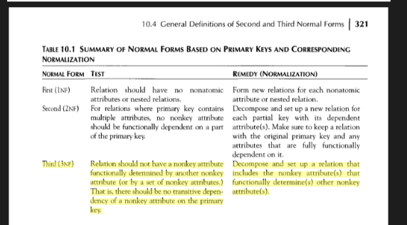

In tables Customers, to ensure 3NF , it has been decomposed so that card details will be fetched from the bank itself.

If we had included other card_details like balance, cvv in the Customers table itself, then it would have violated the 3NF form, since there is non-prime attribute (cvv, balance) which would transitively depend on prime attributes. So, we fetch these details directly from the bank database , thereby ensuring 3NF form.

Example which is same as our database as shown in book,

